Data pipelines

Lab 1- Construct a pipeline with insert-only transactions

Estimated completion time
- 60 minutes

Learning objectives
- In this lab, you will gain an appreciation for the complexities involved in creating a full data pipeline that spans the Land, Structure, and Consume layers of the data lakehouse. The implementation you will construct involves a variety of methods of data pipelining, including batch, insert-only, and a full data pipeline.

Activities
- Prepare for the exercise
- Review pipeline dataset
- Review pipeline requirements
- Review initial load dataset
- Simulate initial ingestion to Land layer
- Transform data types
- Enrich the data
- Perform initial load to Structure layer
- Create views for Consume layer
- Execute the pipeline for an incremental ingest
- Perform the incremental ingest again
- Create plan for automation

Step 1 - Prepare for the exercise
- Sign in and verify the students role is selected in the upper-right corner.
- Ensure the aws-us-east-1-free Cluster is reporting a Status of Running.
- In the Query editor, select aws-us-east-1-free in the cluster pulldown.

Note: If you did not previously create a schema, execute the following SQL statement. Make sure that you replace yourname with your actual name, or another identifier that you prefer. Only use lowercase characters and numbers; no special characters or spaces.

CREATE SCHEMA students.yourname;

Step 2 - Review pipeline dataset
For this lab, you will use the publicly available Bluebikes - Hubway dataset. Read more information about Blue Bikes Boston, a bicycle-sharing program based in Boston since 2011.

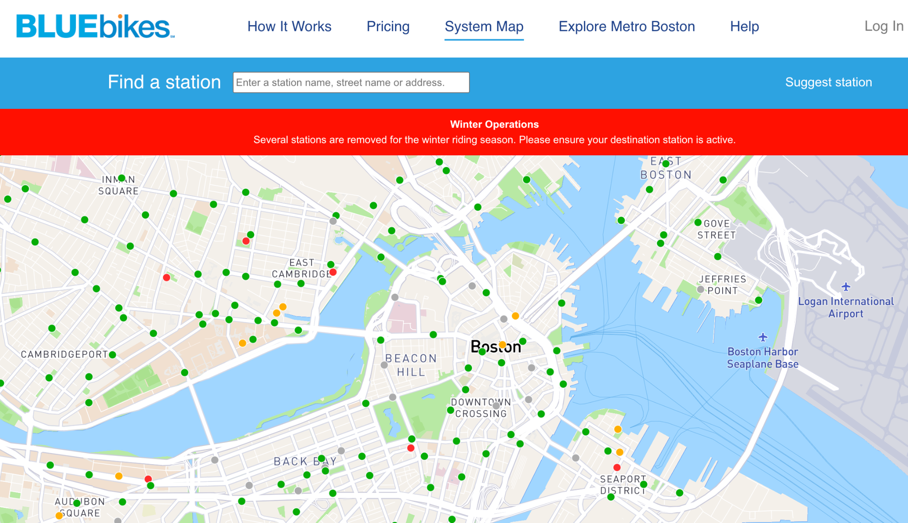

This time, you will be focused on the transactional records of the bike trips from start to finish.

Step 3 - Review pipeline requirements
Creating a data pipeline requires several layers, also known as zones. Each layer will be created separately and will serve a different purpose in the overall pipeline ecosystem.

Review the following high-level requirements to ensure that you understand this reference architecture and each of its three layers before proceeding.

Land layer
- Creates an ingestion process for the bike trips data, which is:
  - Triggered by the creation of a new dataset.
  - Lands raw data into a working table.
- The land layer defines a location on the data lake to store historical raw data

Structure layer
- Transforms data in the Land layer to produce the new, complete, row-level dataset.
- Its objective should be:
  - Ensuring data is of high quality
  - Perform casting of datatypes to most the appropriate type.
  - Augment the records by adding the following columns based on the rider's postal code. These include:
- Province (state for the USA).
- Average income.
Consume layer
- Build a view that calculates minimum, maximum, and average duration by starting station and user type across all rides
- Build a view that calculates hour of day average income based on rider postal code broken out by month

Step 4 - Review initial load dataset
The initial bulk load of trip records is focused on January - September 2022. There is no attempt to build the ingestion process at this time, but it can be simulated. Although you do not have access to S3, there is a directory in the data lake.

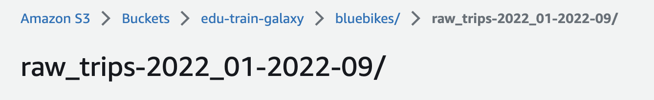

It contains a single file for each of the nine months we are performing our one-time sync-up load.

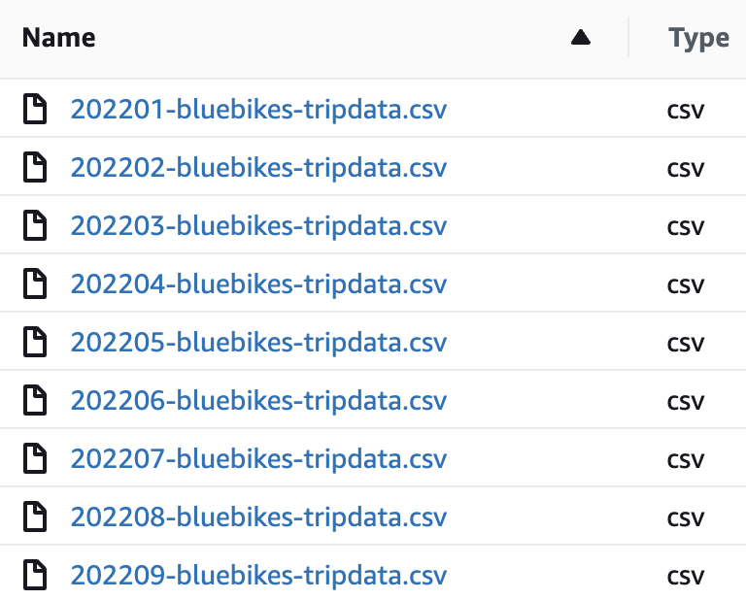

Optionally, you could download one, or more, of these datasets as a zip file by visiting the download page at https://s3.amazonaws.com/hubway-data/index.html, but the lab instructions will use the data already identified above.

Here are a few records from the first file in the list above.

Note: To aid in readability and to avoid line-wrapping of these wide records, the “\” character is used to indicate the next line of indented text is still part of the record that started in the first column.

"tripduration","starttime","stoptime", \
"start station id","start station name", \
"start station latitude","start station longitude", \
"end station id","end station name", \
"end station latitude","end station longitude", \
"bikeid","usertype","postal code"
597,"2022-01-01 00:00:25.1660","2022-01-01 00:10:22.1920", \
178,"MIT Pacific St at Purrington St", \
42.35957320109044,-71.10129475593567, \
74,"Harvard Square at Mass Ave/ Dunster", \
42.373268,-71.118579, \
4923,"Subscriber","02139"
411,"2022-01-01 00:00:40.4300","2022-01-01 00:07:32.1980", \
189,"Kendall T",42.362427842912396,-71.08495473861694, \
178,"MIT Pacific St at Purrington St", \
42.35957320109044,-71.10129475593567, \
3112,"Subscriber","02139"
476,"2022-01-01 00:00:54.8180","2022-01-01 00:08:51.6680", \
94,"Main St at Austin St",42.375603,-71.064608, \
356,"Charlestown Navy Yard", \
42.374124549426526,-71.05481199938367, \
6901,"Customer","02124"

To make sure you can read the input data correctly, verify that the second ride record lasted 411 seconds, started at station 189, ended at station 178, and used bike 3112.

Step 5 - Simulate initial ingestion to Land layer
As this data is ingested as text files, we will use the Hive connector as it supports more file formats than the more modern table formats such as Iceberg. More specifically, we are ingesting comma-separated values for each record. We will use the CSV file type that can handle the quoted-fields seen in the sample data.

A consequence of this file type is that we can only use the varchar datatype for each column. Fortunately, this works well with our strategy of keeping all raw data exactly as received and also allows potentially low-quality, or even invalid, data to be stored by avoiding issues that are applied to other, more restrictive, data types.

Create an ingest table in our logical Land layer to temporarily house the data being ingested.

Note: In a production environment, significant effort would have gone into establishing an appropriate catalog.schema.table naming convention. For this lab, all tables will be created in your schema within the students catalog. For example, the bluebikes.land.temp_ingest_trips table. The tables created in this lab will be an abbreviated form of this possible naming scheme.

USE students.yourname;

CREATE TABLE bb_land_temp_trips (
trip_seconds varchar,
start_time varchar,
stop_time varchar,
start_station_id varchar,
start_station_name varchar,
start_station_latitude varchar,
start_station_longitude varchar,
end_station_id varchar,
end_station_name varchar,
end_station_latitude varchar,
end_station_longitude varchar,
bike_id varchar,
user_type varchar,
postal_code varchar
) WITH (
type = 'HIVE', format = 'CSV', csv_separator = ',',
csv_quote = '"', skip_header_line_count = 1,
--EXTERNAL table as ingestion process landed data
external_location = 's3://edu-train-galaxy/bluebikes/raw_trips-2022_01-2022-09/'
);

List the newly created table’s columns and inspect the data contained in it.

SELECT * FROM bb_land_temp_trips LIMIT 10;

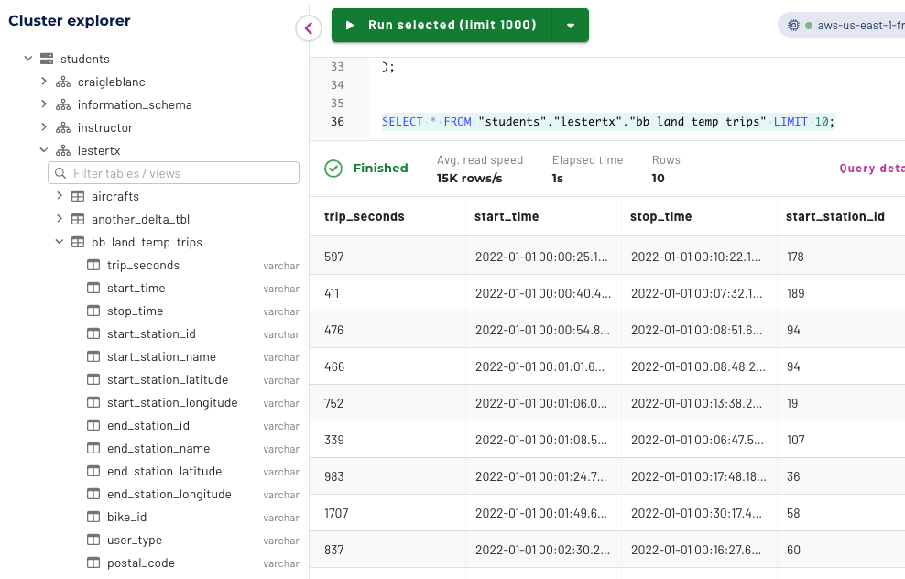

The directory used for the ingestion process corresponds to the external table’s location on the data lake. New data will land in this directory. As we will see later, the underlying data files will be moved into a final resting location within the Land layer along with all previously-ingested data after it has been transformed into the Structure layer.

Note: Normally, the external_location property would be a consistent directory, but for future ingestion data, you will recreate the table referencing another location. This is happening as we are not fully automating the end-to-end data pipeline and will not move the temporary ingestion data into its final location.

Step 6 - Transform data types
All of the columns in the bb_land_temp_trips table are of data type varchar. In practice, a data engineer would work through all columns to check which data type would be most appropriate. They would then perform some inspection of the data present to verify if any particular validity checks need to be implemented and/or if any transformations are required.

For example, the following query’s results suggest the trip_seconds column could easily be placed into a numeric datatype as the existing varchar column’s boundaries appear to be valid.

SELECT min(trip_seconds), max(trip_seconds)
FROM bb_land_temp_trips;

Based on that observation, it appears that we could simply cast the column to use an integer datatype. While working on column by column, create a SELECT statement that keeps growing with the next column until you address all of them.

Note: At this point, there is no need to store the results during this exploration effort until after we address all columns.

SELECT CAST(trip_seconds AS int) AS trip_seconds
FROM bb_land_temp_trips;

The next two columns represent specific timestamp values. Try to perform a similar cast on both of them using the code below.

Note: Remember to add these to the ongoing query.

SELECT
CAST(trip_seconds AS int) AS trip_seconds,
CAST(start_time AS timestamp(6)) AS start_time,
CAST(stop_time AS timestamp(6)) AS stop_time
FROM bb_land_temp_trips;

Note: Typically, it is considered best practice to conduct deeper analysis to verify that the values are casting correctly to the timestamp datatype. However, for this lab, this check is unnecessary.

You can also simulate that you did the proper due diligence and found out that all of the columns, except for the last, were being received with high quality and could be transformed into their appropriate column types. You will see the full set of data type conversions just below. For now, focus on the last column, postal_code.

SELECT min(postal_code), max(postal_code)
FROM bb_land_temp_trips;

The results look like this.

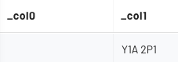

What does it mean? For starters, the value on the right indicates there are Canadian postal codes present. If you explore further, you will find the majority of the values are USA postal codes. There are possibly postal codes from even more countries. There are also some empty strings. Are there more than just a few?

SELECT count()
FROM bb_land_temp_trips
WHERE postal_code = '';

Are there any values that start with a space?

SELECT count()
FROM bb_land_temp_trips
WHERE postal_code LIKE ' %';

Upon further analysis, assume you determined there are some records that are intended to indicate the field was null.

SELECT count()
FROM bb_land_temp_trips
WHERE postal_code = 'NULL';

This can be fixed using the two functions together. The innermost function below is “replace” ; it will replace NULL with an empty string (i.e. ''). The outermost function below is “nullif” ; it will take all of the empty strings and set them to a true “NULL” value. Since the innermost function runs first this means that both the original and new empty strings are all set to NULL.

SELECT
nullif(replace(postal_code, 'NULL', ''), '')
FROM bb_land_temp_trips;

Putting all of the data type conversion activities together, you will have this query. Notice that there are a few columns where no conversions are needed, such as user_type.

SELECT
CAST(trip_seconds AS int) AS trip_seconds,
CAST(start_time AS timestamp(6)) AS start_time,
CAST(stop_time AS timestamp(6)) AS stop_time,
CAST(start_station_id AS int) AS start_station_id,
start_station_name,
CAST(start_station_latitude AS decimal(15,13))
AS start_station_latitude,
CAST(start_station_longitude AS decimal(16,13))
AS start_station_longitude,
CAST(end_station_id AS int) AS end_station_id,
end_station_name,
CAST(end_station_latitude AS decimal(15,13))
AS end_station_latitude,
CAST(end_station_longitude AS decimal(16,13))
AS end_station_longitude,
CAST(bike_id AS int) AS bike_id,
user_type,
nullif(replace(postal_code, 'NULL', ''), '')
AS postal_code
FROM bb_land_temp_trips;

This was a simplified version of what this initial activity might require depending on the number of columns present and the quality of the data being ingested.

Step 7 - Enrich the data
The enrichment requirements declared the records need to be augmented by adding province and average income values based on rider postal code. As the following query shows, there is an existing lookup table that can be utilized. As the table name suggests, it only contains USA-based zip codes. Here are the columns we can leverage for our enrichment needs.

SELECT zip_code, state,
format_number(tot_inc_avg * 1000) AS avg_income
FROM lakehouse.global.zip_code_income
WHERE zip_code IN
(30004, 30009, 30022, 30075, 30076, 30092);

The zip codes used above are for Roswell, Georgia, USA. If you know enough about a specific USA zip code, run this query again to see if the results are similar to what you are expecting. If you do not have a zip code to try, use 90210, which is Beverly Hills, California, USA.

Verify that the two postal_code values present in Step 3’s sample data are present in the zip code lookup table.

SELECT * FROM lakehouse.global.zip_code_income
WHERE zip_code IN (02139, 02124);

Notice anything about the results for these two USA zip codes?

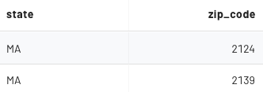

The zip_code column is of type INT, and thus the leading zero is missing in the results. Verify that these two values will join correctly based on the fact that the bb_land_temp_trips.postal_code is, and will remain, a varchar datatype.

SELECT t.postal_code, z.tot_inc_amt
FROM bb_land_temp_trips AS t
JOIN lakehouse.global.zip_code_income AS z ON (
cast(t.postal_code as INT) = z.zip_code)
WHERE postal_code IN ('02139', '02124');

To expedite the lab exercise, assume in your analysis of the data to be ingested you identified the following potential concerns
- The inability to cast the postal_code column to the INT data type due to these conditions that are present
  - Canadian postal codes and possibly other unknown string formats
  - Empty strings
  - Strings with a hard-coded value of NULL
  - Values with a dash in them indicating the USA’s ZIP+4 format
- Values in postal_code column that are not in the zip_code_income table, including
  - 99999
  - 00000

Further assume that you were able to produce the following SQL that identifies how to augment the ingestion data with the state name and average income from the zip_code_income table.

SELECT CAST(t.trip_seconds AS int) AS trip_seconds,
nullif(replace(t.postal_code, 'NULL', ''), '') AS postal_code,
cast(z.state AS VARCHAR(2)) as province,
z.tot_inc_avg * 1000 AS avg_income
FROM bb_land_temp_trips AS t
LEFT JOIN lakehouse.global.zip_code_income AS z
ON (try_cast(split_part(nullif(replace(t.postal_code, 'NULL', ''), ''), '-', 1) AS int) = z.zip_code);

Your results should be similar to these.

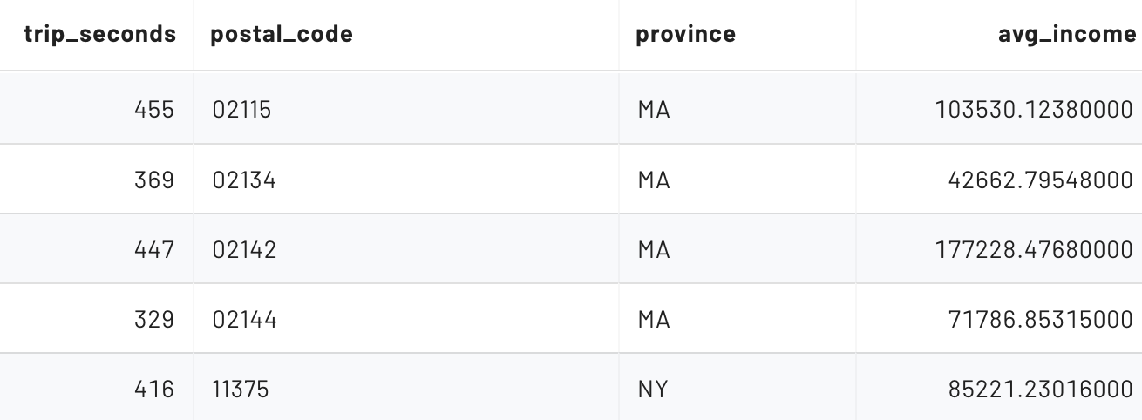

For any value that cannot be joined on the lookup table, null values will be used for the augmented fields.

Step 8 - Perform initial load to Structure layer
Build a single transformation query by melding together the data conversions/casting efforts along with the enrichment activities. As this is our initial load of the Structure layer table, you can use the Create Table As Select (CTAS) approach to build the table to store this sync-up effort. This table will be used to store high-quality in future instances of this data pipeline you are constructing.

CREATE TABLE bb_structure_trips
WITH (type='iceberg', format='orc') AS (
SELECT
CAST(t.trip_seconds AS int) AS trip_seconds,
CAST(start_time AS timestamp(6)) AS start_time,
CAST(stop_time AS timestamp(6)) AS stop_time,
CAST(t.start_station_id AS int) AS start_station_id, t.start_station_name,
CAST(t.start_station_latitude AS decimal(15,13)) AS start_station_latitude,
CAST(t.start_station_longitude AS decimal(16,13)) AS start_station_longitude,
CAST(t.end_station_id AS int) AS end_station_id, end_station_name,
CAST(t.end_station_latitude AS decimal(15,13)) AS end_station_latitude,
CAST(t.end_station_longitude AS decimal(16,13)) AS end_station_longitude,
CAST(t.bike_id AS int) AS bike_id, t.user_type,
nullif(replace(t.postal_code, 'NULL', ''), '') AS postal_code,
cast(z.state AS VARCHAR(2)) as province,
cast(round(z.tot_inc_avg * 1000) AS INT) AS avg_income
FROM
bb_land_temp_trips AS t
LEFT JOIN lakehouse.global.zip_code_income AS z ON (
try_cast(
split_part(
nullif(replace(t.postal_code, 'NULL', ''), ''), '-', 1
) AS int
) = z.zip_code
)
);

After a cursory review of the new table, validate that the temporary ingestion table has the same number of records as the newly constructed Structure table.

SELECT count() FROM bb_land_temp_trips;
SELECT count() FROM bb_structure_trips;

They both should identify 2,906,784 rows present.

To assist the Cost-based optimizer in creating the best possible query plan, calculate statistics on this new table.

ANALYZE bb_structure_trips;

You created an Iceberg table with the ORC file format as you want this Structure layer table to be performance-oriented and transaction capable.

At this point in the pipeline, you would normally move the underlying data lake files from the external_location of the bb_land_temp_trips table to the data lake folder backing the table that will keep all raw data within. That table is not being created in this lab as you do not have access to the S3 object store to perform the necessary file moves.

Note: With the naming scheme we have been using, that table would be called bb_land_raw_trips in your schema. A possible production name might be bluebikes.land.raw_trips.

Step 9 - Create views for Consume layer
As presented in Step 2, the following are the requirements for datasets in the Consume layer:
- Build a view that calculates minimum, maximum, and average duration by starting station and user type across all rides
- Build a view that calculates hour of day average income based on rider postal code broken out by month

The following SQL creates a view to support the first reporting requirement.

CREATE VIEW
bb_consume_dur_aggs_by_strt_stat_and_usr_typ
AS (
SELECT start_station_id, user_type,
min(trip_seconds) AS min_trip_seconds,
max(trip_seconds) AS max_trip_seconds,
round(avg(trip_seconds)) AS avg_trip_seconds
FROM bb_structure_trips
GROUP BY start_station_id, user_type
);

Perform a cursory check to verify this view is functional. Additionally, here is a potential consumption of this view.

SELECT *
FROM bb_consume_dur_aggs_by_strt_stat_and_usr_typ
ORDER BY avg_trip_seconds DESC, start_station_id;

The following SQL creates a view to support the second reporting requirement.

CREATE VIEW
bb_consume_avg_inc_by_month_and_hour
AS
WITH dates_decomposed AS (
SELECT substr(cast(date_trunc('month', start_time) AS varchar),
1, 7) AS trip_month,
substr(cast(date_trunc('hour', start_time) AS varchar),
12, 2) AS hr_of_day,
avg_income AS avg_inc_from_with
FROM bb_structure_trips
)
SELECT trip_month, hr_of_day,
round(avg(avg_inc_from_with)) AS avg_income
FROM dates_decomposed
GROUP BY trip_month, hr_of_day;

Perform a cursory check to verify this view is functional. Additionally, here is a potential consumption of this view.

SELECT *
FROM bb_consume_avg_inc_by_month_and_hour
WHERE trip_month = '2022-04'
ORDER BY hr_of_day;

Step 10 - Execute the pipeline for an incremental ingest
As identified in Step 4, the pipeline’s ingestion process is being simulated. To accomplish this, drop the temporary ingest table and recreate it with a different external_location value pointing to the first incremental ingest data for October, 2022.

DROP TABLE bb_land_temp_trips;
CREATE TABLE bb_land_temp_trips (
trip_seconds varchar,
start_time varchar,
stop_time varchar,
start_station_id varchar,
start_station_name varchar,
start_station_latitude varchar,
start_station_longitude varchar,
end_station_id varchar,
end_station_name varchar,
end_station_latitude varchar,
end_station_longitude varchar,
bike_id varchar,
user_type varchar,
postal_code varchar
) WITH (
type = 'HIVE', format = 'CSV', csv_separator = ',', csv_quote = '"',
skip_header_line_count = 1,
--NEW data lake location
external_location = 's3://edu-train-galaxy/bluebikes/raw_trips-2022_10/'
);

Perform a cursory check on this revised table. Validate that there are 416,964 rides in the bb_land_temp_trips table.

Instead of using a CTAS statement, you will use an INSERT statement in the Structure layer table using the same transformations you have used before.

INSERT INTO bb_structure_trips
SELECT
CAST(t.trip_seconds AS int) AS trip_seconds,
CAST(start_time AS timestamp(6)) AS start_time,
CAST(stop_time AS timestamp(6)) AS stop_time,
CAST(t.start_station_id AS int) AS start_station_id,
t.start_station_name,
CAST(t.start_station_latitude AS decimal(15,13))
AS start_station_latitude,
CAST(t.start_station_longitude AS decimal(16,13))
AS start_station_longitude,
CAST(t.end_station_id AS int) AS end_station_id,
end_station_name,
CAST(t.end_station_latitude AS decimal(15,13))
AS end_station_latitude,
CAST(t.end_station_longitude AS decimal(16,13))
AS end_station_longitude,
CAST(t.bike_id AS int) AS bike_id, t.user_type,
nullif(replace(t.postal_code, 'NULL', ''), '')
AS postal_code,
cast(z.state AS VARCHAR(2)) as province,
cast(round(z.tot_inc_avg * 1000) AS INT) AS avg_income
FROM bb_land_temp_trips AS t
LEFT JOIN lakehouse.global.zip_code_income AS z ON (
try_cast(
split_part(
nullif(replace(t.postal_code, 'NULL', ''), ''), '-', 1
) AS int
) = z.zip_code
);
Verify that the Structure layer table, which had 2,906,784 records previously, now has 416,964 more.

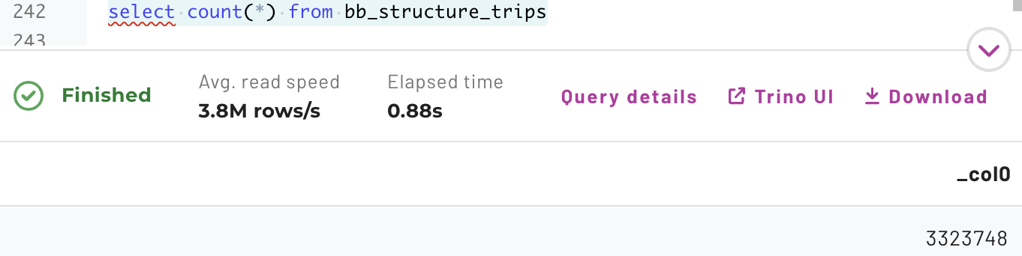

The next step would be to move the temporary ingestion table’s underlying files to the location of the raw table with all historical information. Again, you cannot perform this step as you do not have access directly to S3.

Validate that the Consume layer has been updated with this new data.

SELECT *
FROM bb_consume_avg_inc_by_month_and_hour
WHERE trip_month = '2022-10'
ORDER BY hr_of_day;

Step 11 - Perform the incremental ingest again
Repeat the activities from Step 10:

- To emulate the ingestion process landing files in the external_location of the bb_land_temp_trips table
  - Drop the table
  - Create it again using the S3 folder ending with raw_trips-2022_11/ for the external_location property
- Run the INSERT statement into the Structure table from the Land table just recreated
- Validate there are 3,614,369 total number of records present in the Structure table
- Verify the Consume view(s) reflect this new data

Step 12 - Create plan for automation
At this point, you have validated the data pipeline three times. Once with the initial bulk load and then two more times performing incremental loads. You execute the steps of this batch ingestion pipeline manually.

An appropriate next step would be to automate and schedule the entire pipeline so it can run unattended. Tools such as Apache Airflow and dbt are possible tools to leverage in this effort.

Automating this pipeline is outside the scope of lab exercise, but in production, this would be a critical step to complete.

END OF LAB EXERCISE

